NETLOOK – Network Lookup for z/OS
Oct 15, 2026 · @Rama Sachdeva
A lightweight, read-only REXX/ISPF toolkit that gives an overview of the z/OS network setup and helps diagnose network problems. In one screen it shows which job owns each port, which LPAR owns each IP, what is listening, and what is connected to what, across every LPAR in the sysplex.
- No network expertise needed
- Installs in about five minutes
- Issues only DISPLAY commands, so nothing is changed
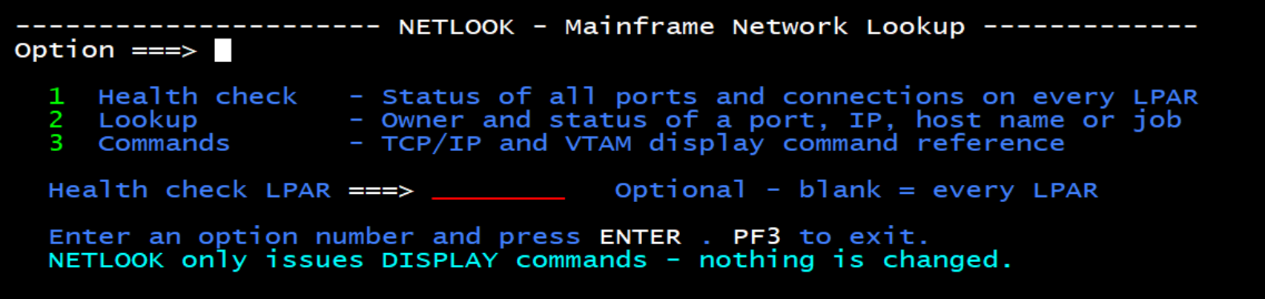
NETLOOK main menu

Why
Many shops have no dedicated network team. When a website, FTP transfer or connection fails, the z/OS sysprog has to run and interpret many display commands. NETLOOK runs them for you and summarizes the answer in plain English, so the problem can be shortlisted quickly.

Install
Upload members as text (ASCII to EBCDIC, CRLF), not binary.
- Allocate two PDS libraries (RECFM FB, LRECL 80), e.g. YOUR.NETLOOK.EXEC and YOUR.NETLOOK.PANELS.
- Upload rexx/NETLOOK.rexx as member NETLOOK in the exec library.
- Upload panels/NETLOOKP.panel and panels/NETLKUP.panel as members NETLOOKP and NETLKUP in the panel library.
- In NETLOOK's Site configuration block, set:
  - cfg.panlib to your panel library (NETLOOK allocates it with LIBDEF itself)
  - stackname. to your TCP/IP started task name, if it is not TCPIP
  - For each other LPAR in the sysplex, stackname.LPARNAME = 'tcpip_stc' with that LPAR's TCP/IP started task name (needed whenever it differs from the default)
- From ISPF, run TSO EX 'YOUR.NETLOOK.EXEC(NETLOOK)', or TSO %NETLOOK if the library is in SYSEXEC/SYSPROC.

Options
Option | What it does
1 Health check | Status of every reserved or listening TCP port on every LPAR, plus a connection map (which STC is connected to which remote IP/host)
2 Lookup | By PORT, IP, HOST or JOB: owner, LPAR, listening status, connection health
3 Commands | Built-in TCP/IP and VTAM display command reference
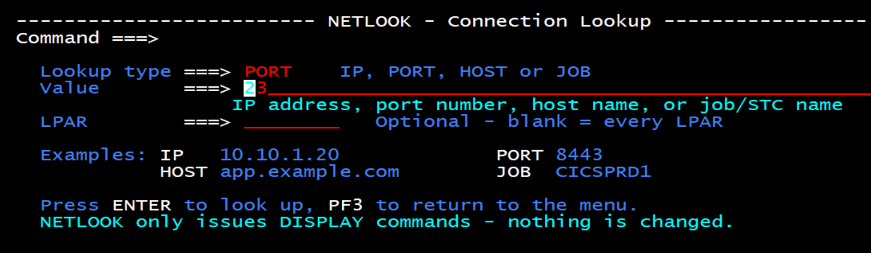
Option 2 – Lookup panel
Health-check statuses: OK · WARN (stuck SYNRCVD/CLOSWAIT) · DOWN (owner not running) · NOT LSTN (running, not listening) · STANDBY (up on another LPAR) · BLOCKED (PORT … RESERVED).

What it runs
Per LPAR, with RO sysname, added for remote LPARs:
- D TCPIP,<stack>,NETSTAT,ALLCONN | PORTLIST | HOME | VIPADYN,MAX=*
- SDSF SYS (find LPARs) and DA (is the job running?)
- Resolver lookups for host names

Settings
Setting | Default | Purpose
cfg.panlib | YOUR.NETLOOK.PANELS | Panel library (must change)
stackname. | TCPIP | TCP/IP started task name on the LPAR you run from
stackname.LPARNAME | (none) | TCP/IP started task name for each other LPAR, e.g. stackname.SYSB = 'TCPIPB'
cfg.syslist | blank | Blank = find all sysplex LPARs automatically
cfg.delay | 5 | Seconds to wait for command replies; raise it if NOTES says "looks incomplete"
cfg.rdns | 1 | Show host names for remote IPs; 0 = IPs only

Authorities
All are display-only. Typical profiles (names vary by site):
- SDSF: ISFCMD.ODSP.ULOG.*, ISFCMD.DSP.ACTIVE.*, ISFCMD.ODSP.SYSTEM.*
- OPERCMDS: MVS.MCSOPER.userid, MVS.DISPLAY.TCPIP, MVS.ROUTE.CMD.*

Notes
- Tested on z/OS 3.1 in a multi-LPAR sysplex.
- v1 limits: IPv4 and TCP only, one TCP/IP stack per LPAR, current state only.
- Troubleshooting: run %NETLOOK PORT 23 DEBUG from ISPF option 6 to see the raw command replies.

License
Apache License 2.0 · © 2026 Rama Sachdeva

